Assignment 1
Title: Store and Display Elements Using ArrayList
Problem Statement: Create an ArrayList to store 5 student names and display all names.
Expected Outcome: All student names should be printed one by one.
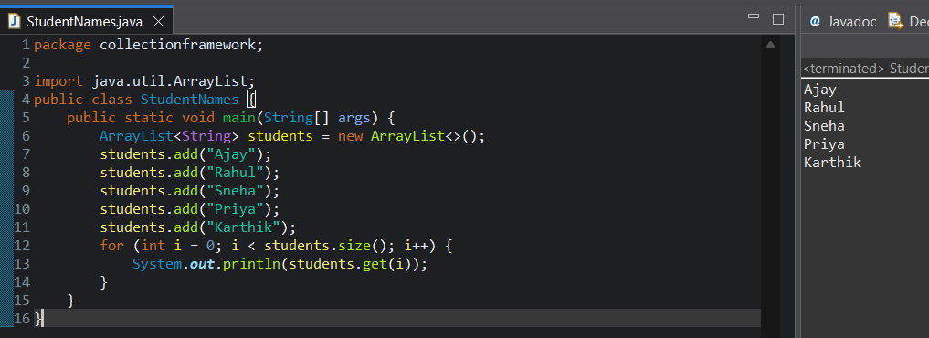
Assignment 2
Title: Add and Remove Elements from ArrayList
Problem Statement: Create an ArrayList of integers. Add 5 numbers and remove one number.
Expected Outcome: Updated list should be displayed after removal.
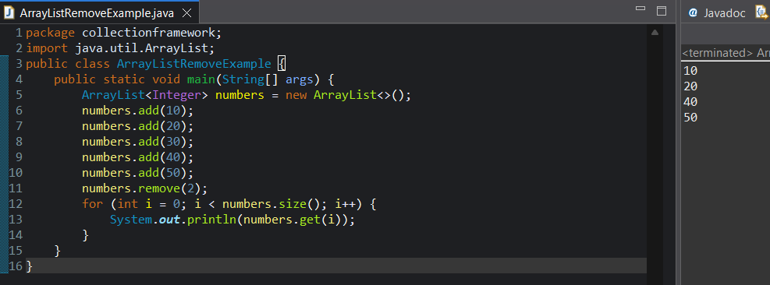

Assignment 3
Title: Find Size of Collection
Problem Statement: Create an ArrayList of city names and find how many cities are stored.
Expected Outcome: Total number of cities should be displayed.
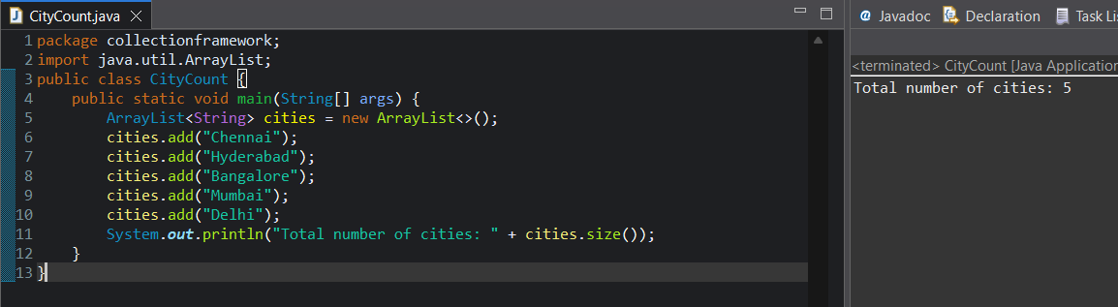
Assignment 4
Title: Iterate Collection Using for-each Loop
Problem Statement: Store 5 course names in an ArrayList and display them using a for-each loop.
Expected Outcome: All course names printed successfully.
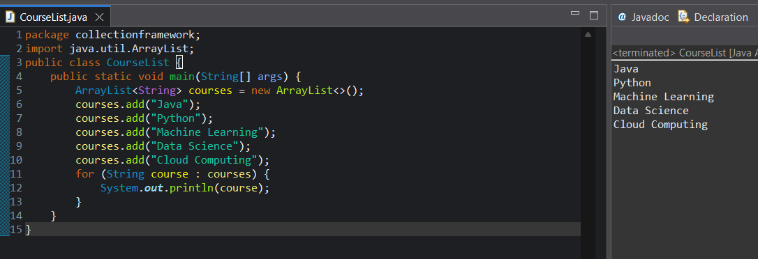

Assignment 5
Title: Check Element Exists in List
Problem Statement: Create an ArrayList of fruits and check whether "Apple" exists.
Expected Outcome: Program should print whether Apple is present or not.
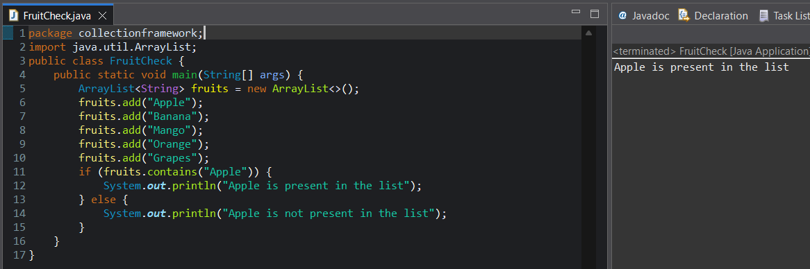
Assignment 6
Title: Store Unique Elements Using HashSet
Problem Statement: Create a HashSet and add duplicate numbers.
Expected Outcome: Duplicates should not be stored.
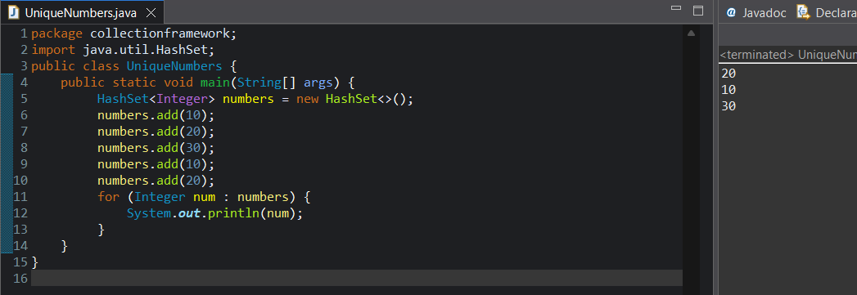

Assignment 7
Title: Display HashSet Elements
Problem Statement: Store 5 colors in a HashSet and display them.
Expected Outcome: All colors printed (order not important).
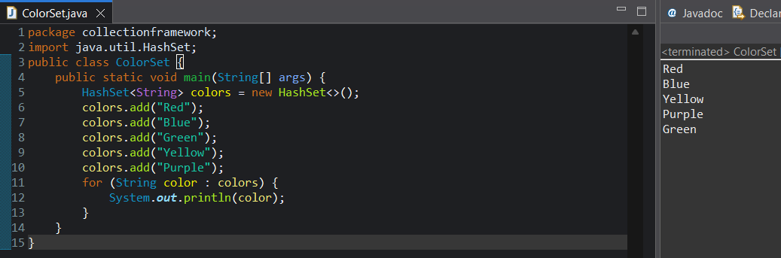
Assignment 8
Title: Basic Key-Value Storage Using HashMap
Problem Statement: Create a HashMap to store employee ID and employee name.
Expected Outcome: Employee details printed correctly.
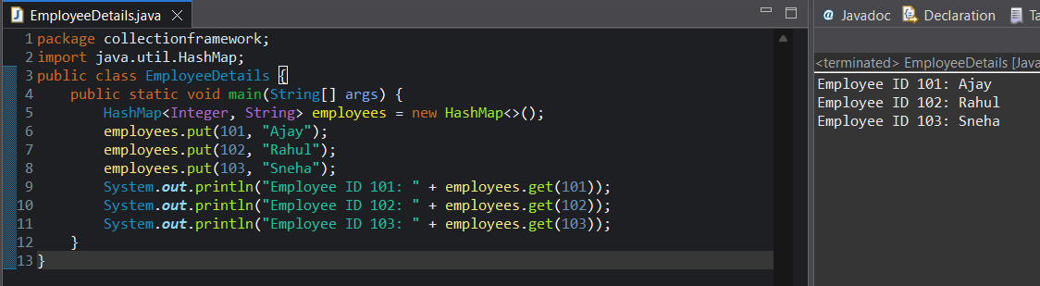
Assignment 9
Title: Display All Keys and Values from HashMap
Problem Statement: Store 3 country codes and country names in a HashMap.
Expected Outcome: All keys and values printed.
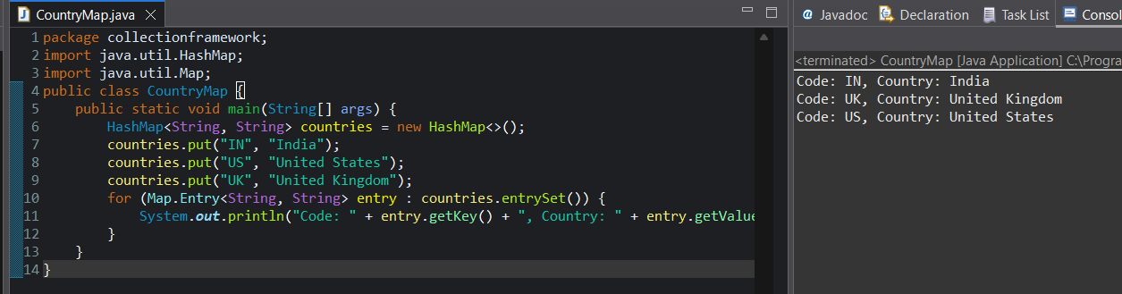
Assignment 10
Title: Remove Entry from HashMap
Problem Statement: Remove one employee entry from a HashMap.
Expected Outcome: Remaining entries printed.
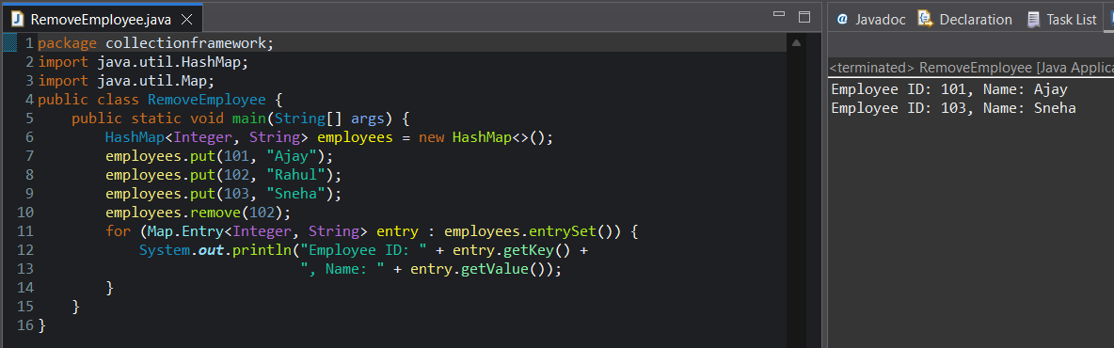
Assignment 11
Title: Use LinkedList to Store Elements
Problem Statement: Store 5 numbers using LinkedList and display them.
Expected Outcome: All elements printed.
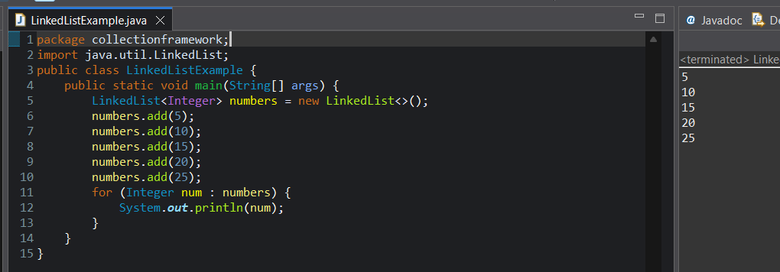
Assignment 12
Title: Check Collection Is Empty
Problem Statement: Create an ArrayList and check whether it is empty.
Expected Outcome: Program should print true or false.
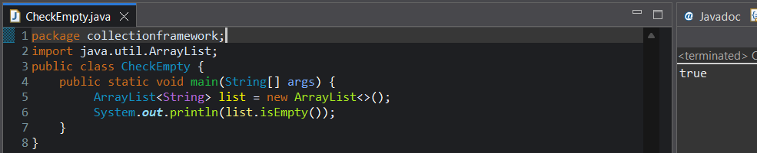
Assignment 13
Title: Clear All Elements from Collection
Problem Statement: Add elements to an ArrayList and remove all elements.
Expected Outcome: List should be empty.
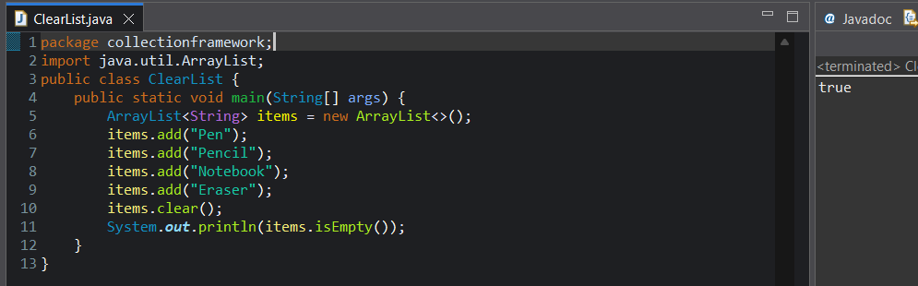
Assignment 14
Title: Store Different Data Types Using Wrapper Classes
Problem Statement: Store integer values using wrapper class in an ArrayList.
Expected Outcome: Values stored and printed successfully.
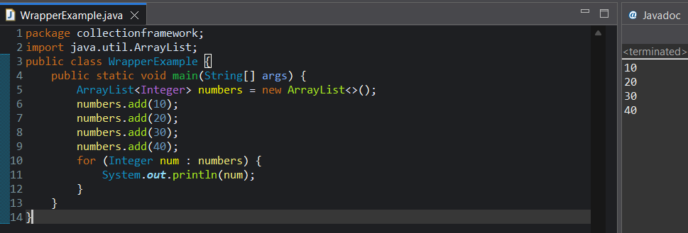

Assignment 15
Title: Convert Collection to Array
Problem Statement: Convert an ArrayList of strings to an array.
Expected Outcome: Array elements printed.
